SCHOOLOFCOMPUTER SCIENCE AND ARTIFICIAL INTELLIGENCE |  |  |  |  | DEPARTMENTOFCOMPUTER SCIENCE ENGINEERING
ProgramName: M. Tech/MCA/MSC |  |  |  | AssignmentType: Lab |  |  | AcademicYear:2025-2026
CourseCoordinatorName |  |  |  | Venkataramana Veeramsetty
CourseCode |  |  |  | CourseTitle |  | AI Assisted Problem Solving Using Python
Year/Sem |  |  | II/I | Regulation |  | R25
DateandDay  of Assignment |  |  | Week5 - Tuesday | Time(s)
Duration |  |  | 2 Hours | Applicableto  Batches |  | M. Tech/MCA/MSC
AssignmentNumber:14.3(Presentassignmentnumber)/24(Totalnumberofassignments)
 | Q.No. | Question |  |  |  |  |  | ExpectedTime  to complete
 | 1 | Lab 14 – Web Frontend Development: AI-assisted HTML/CSS/JS with Python  Lab Objectives  - To understand how AI can generate HTML/CSS/JS templates.  - To practice integrating frontend and backend (Python) for small apps.  - To evaluate AI-generated code for readability, reusability, and responsiveness.  Learning Outcomes  After completing this lab, students will be able to:  - Generate HTML/CSS layouts using AI tools.  - Add JavaScript interactivity with AI suggestions.  - Integrate basic Python (Flask/Streamlit) backend to serve frontend.  - Evaluate AI-generated web code for responsiveness and usability.  - Debug and refine AI-generated frontend code.  Task Description #1 – AI-generated HTML Page  Task: Ask AI to generate a simple HTML homepage for a "Student Info Portal" with a header, navigation menu, and footer.  Expected Output:  - HTML code with <header>, <nav>, <footer>.  - Clean indentation, proper tags, and comments.  Code:  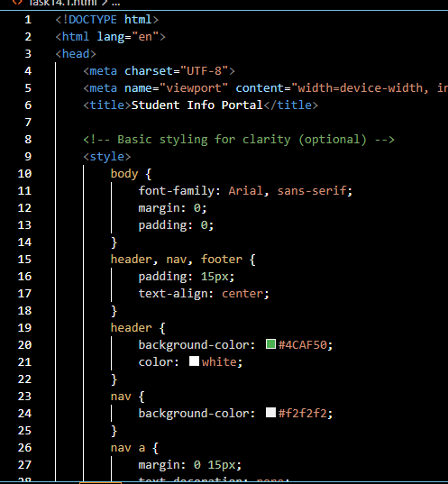  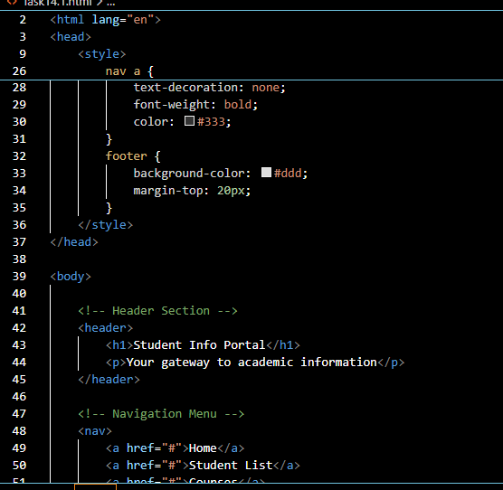  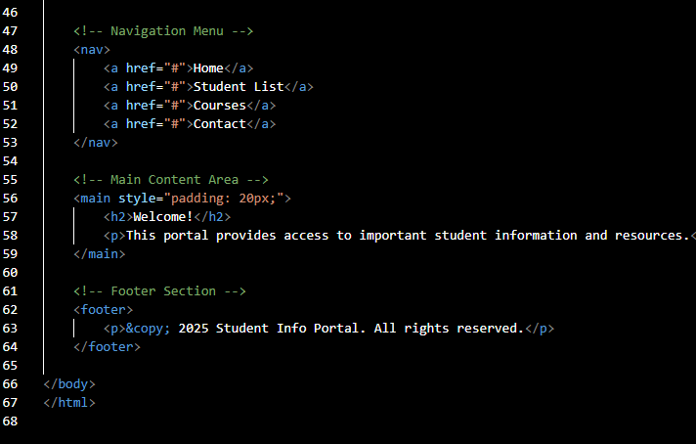  Output:  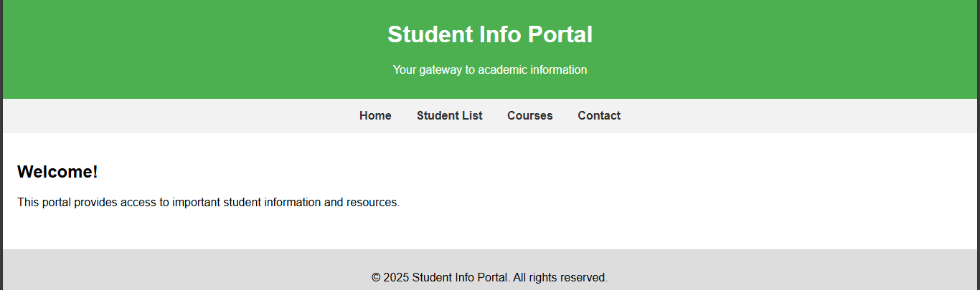  Task Description #2 – CSS Styling  Task:  Use AI to add CSS styling to Task #1 homepage for:  - Responsive navigation bar.  - Centered content section.  - Footer with light gray background.  Expected Output:  - HTML + CSS combined.  - AI explains how CSS classes apply.  Expected Output: AI refactors with withopen() and try-except:  Code:  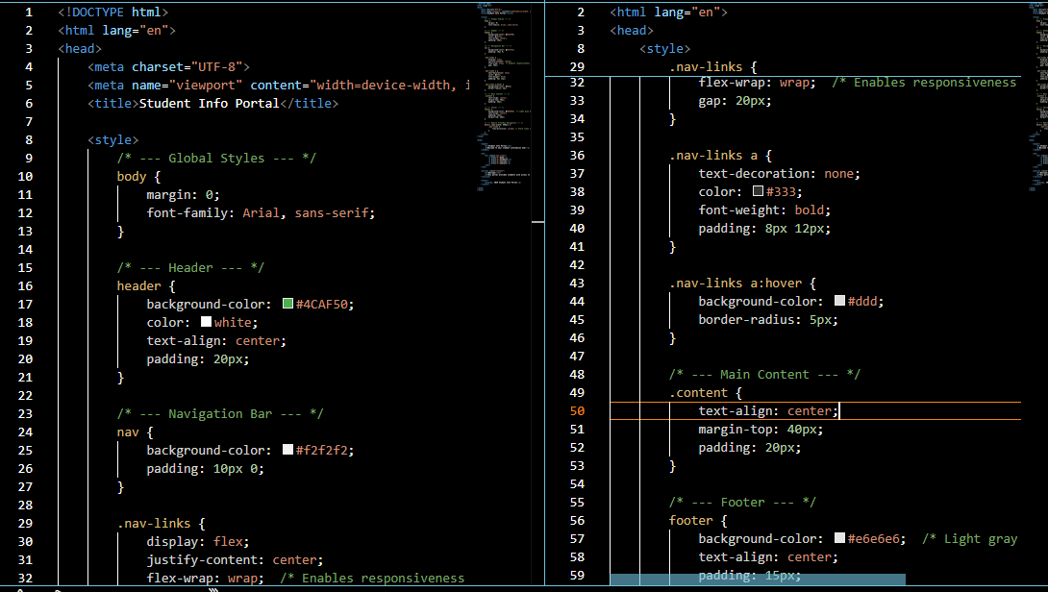  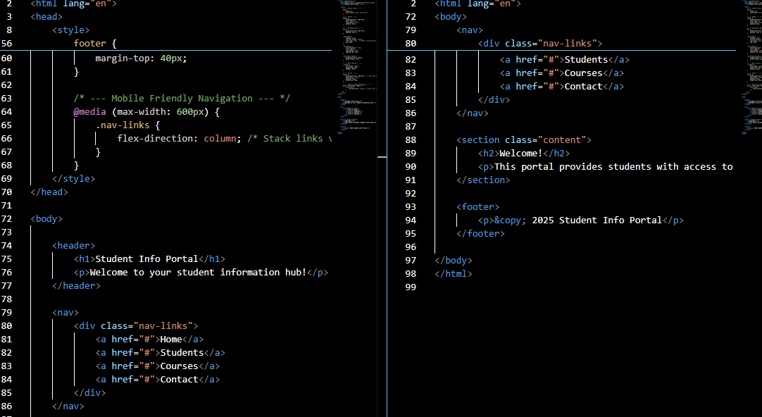  Output:  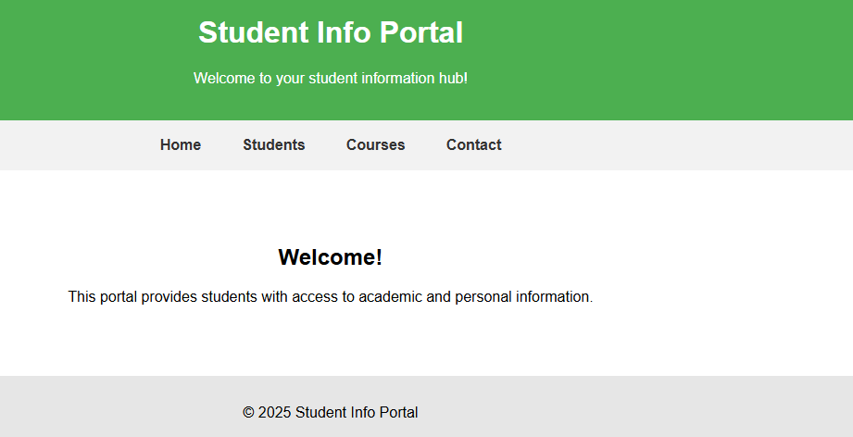  Task Description #3 – JavaScript Interactivity  Task: Prompt AI to generate a JS script that validates a simple login form (non-empty username/password).  Expected Output:  Working on submit JS validation.  Clear error messages if inputs are empty.  Code:  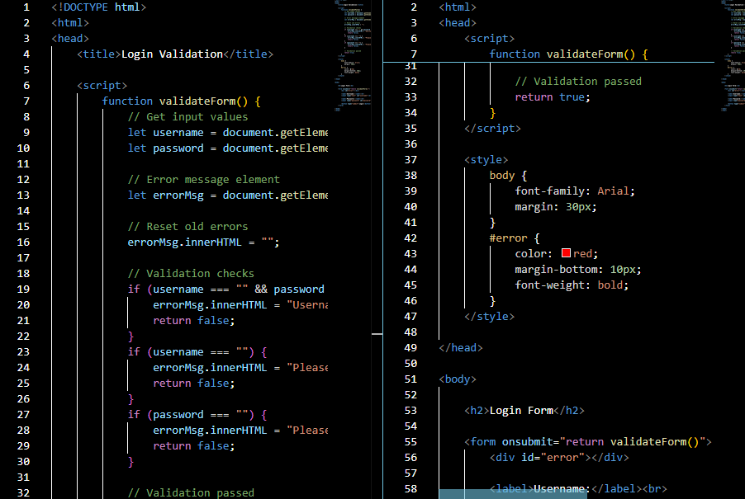  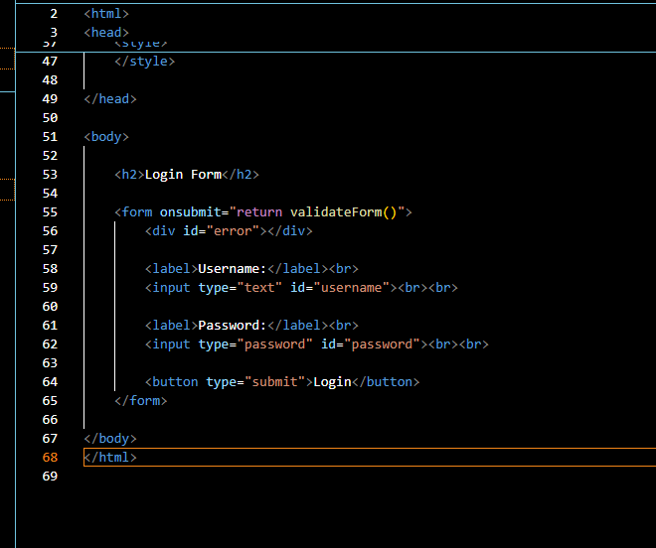  Output:  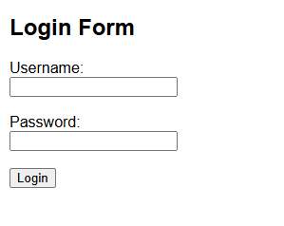  Task Description #4 – Python Backend Integration  Task: Ask AI to generate a Flask app that serves the HTML form (Task #3) and prints the username on successful login.  Code:  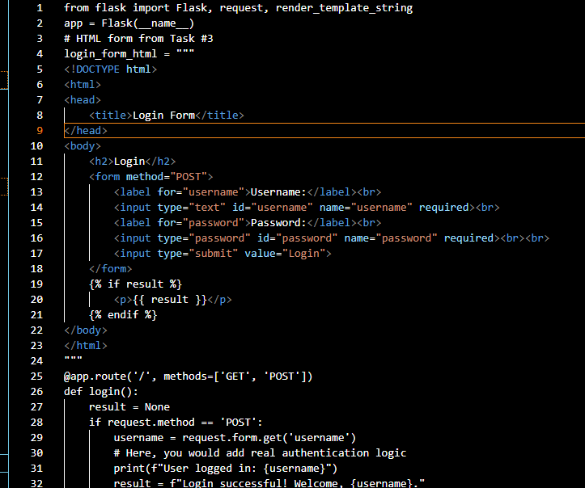  Output:  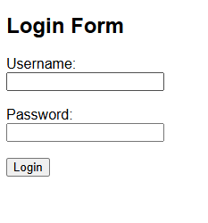  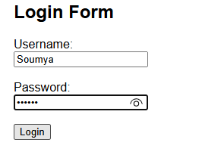  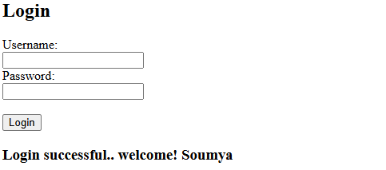 |  |  |  |  |  | Week5 - Tuesday

